CARDIAC TUBERCULOMA PRESENTING AS THROMBOTIC THROMBOCYTOPENIC PURPURA-HEMOLYTIC UREMIC SYNDROME
E.A. Christian, R.M. Mehta, R.N. Khouzam
University of Tennessee Health Sciences Center, Memphis, TN, USA

Objective: To review a rare case of Thrombotic Thrombocytopenic Purpura-Hemolytic Uremic Syndrome (TTP-HUS) as a sequelae of tuberculosis; complicated by tuberculous endocarditis.
Background: Herein we discuss the case of a 25-year-old female who presented with complaints of confusion, fevers, night sweats, weight loss, as well as blurred vision over the course of 2 months. Of note, her father was diagnosed with active tuberculosis when the patient was 6 years old, and her own past medical history was significant for a pericardial effusion at age 9.
Method and Results: Laboratory studies were notable for pancytopenia with schistocytes, elevated lactate dehydrogenase, and an elevated serum creatinine level consistent with TTP-HUS. She subsequently underwent a 10 day course of plasmapheresis. In spite of these efforts, she had minimal clinical improvement and persistent fever. In the course of her work up, she had an echocardiogram which revealed a left atrial mass measuring in centimeters (cm) 7.0 cm x 2.8 cm x 2.6 cm. Given the patient’s history, imaging, and histopathology of the resected mass, she was treated for tuberculous endocarditis which resulted in complete clinical resolution of her symptoms.
Conclusion: TTP-HUS is a rare sequela of infective endocarditis. Even more uncommon are tuberculomas associated with tuberculosis; which are typically seen in the central nervous system of immunocompromised individuals. However, in this rare case, we encountered an immunocompetent patient who initially presented with a diagnosis of TTP-HUS, only later to unearth a large left atrial mass found to be consistent with tuberculous endocarditis.

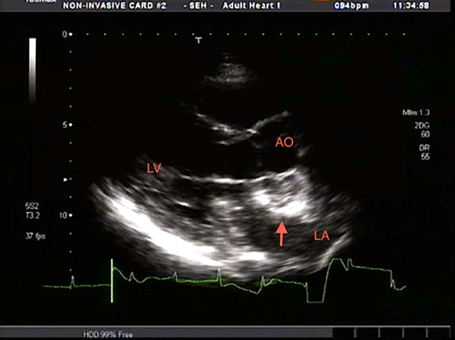

Transthoracic echocardiogram in the parasternal long axis view demonstrating the tuberculoma in the left atrium (upward arrow).

